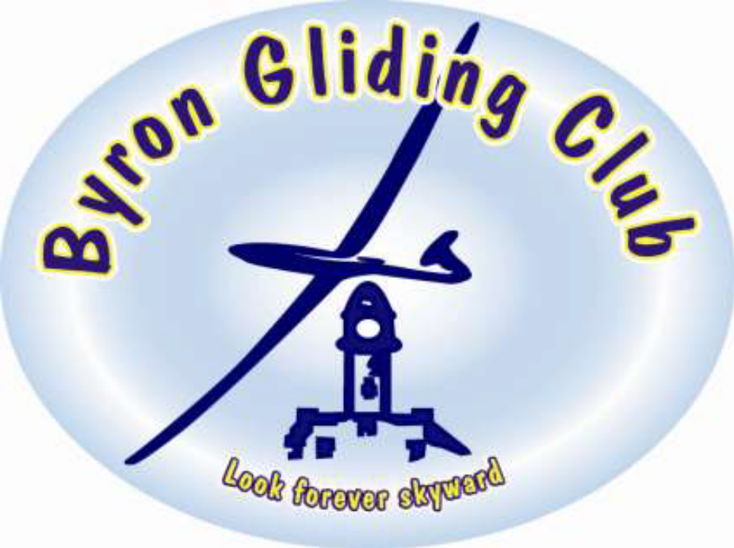

Members
Introduction Manual

Welcome
To the Byron Gliding Club Inc.
We hope you enjoy your association with us and enjoy your flying activities.

ABOUT THE CLUB
We are a not-for-profit Club incorporated under the NSW Associations Act 2009. The Club Model Rules adopted under this Act are available online at the Fair Trading website or can be inspected at any time by members at the Clubhouse.
The Club has operated from the Tyagarah Airfield since 1992. Our site on the eastern end of the airstrip is on Crown land and we sublease this from the Byron Shire Council who operate and manage the airfield. The club has increased in size over the years from a beginning membership of 7 to a maximum membership of 70. The current membership fluctuates annually from around 30 to 50 members. Our Club is primarily run by a Management Committee which is elected each year by the members at our Annual General Meeting. This Committee usually meets monthly at the Clubhouse at an agreed time and members are encouraged to attend and get involved in the operation of the Club.

CONTACT INFORMATION
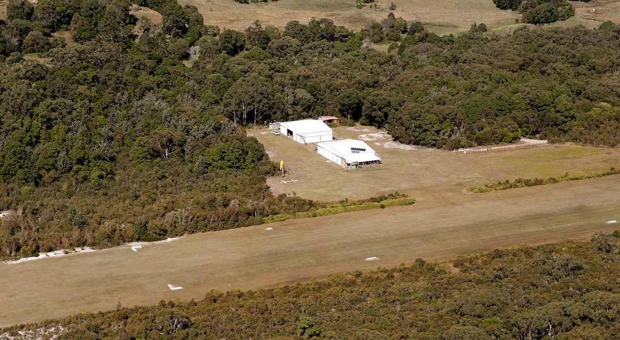
www.byrongliding.com

CLUB MANAGEMENT
There are two committees or panels involved with the operation of the club:
The Management Committee is responsible for the day-to-day running of club operations, finances and marketing and usually comprises of the following:
President
Vice President
Secretary
Treasurer
3 Ordinary Committee Members (one of which will be the Chief Flying Instructor)

The Instructor Training Panel looks after all aspects of training, airmanship and safety and consists of GFA approved instructors of varying grades from Level 1 to Level 3, one of which is nominated by the panel members as the club’s Chief Flying Instructor or “CFI”.

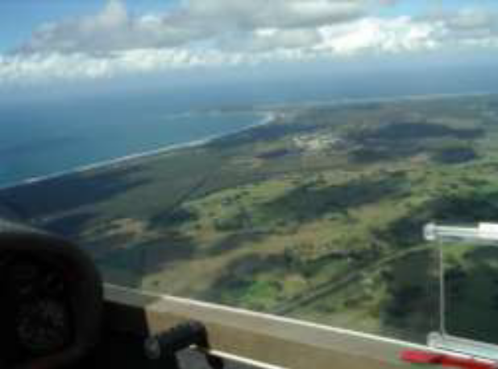
Club Airworthiness Officer is involved with the safety, airworthiness and maintenance of the club aircraft.

Web Site Co-ordinator maintains the club’s internet website and email facilities.

INTRODUCTION
This manual is designed to help new (and maybe old) members get involved in the operation of our Club and to assist them to become familiar with “the way things are done around here”.

MEMBERSHIP
There are a number of options for membership which are explained below:
Full Member – a full member is a member who flies and joins for 1 year. Full members may nominate new members and vote at General Meetings of the Club. Students studying full time up to age 25 and Centre Link Pension members over 65 or Centre Link Disability pensioners may apply to the Committee for a discounted membership fee equivalent to an associate member with full rights.
Associate Members – there are a number of categories of associate members. They include members who wish to be short term i.e. 3 months, full-time members of other gliding clubs who wish to fly semi-regularly at our Club and others who wish to fly on rare occasions or just support our Club. Associate members may participate at Committee Meetings but can not vote at General Meetings unless given leave to do so by the current committee.

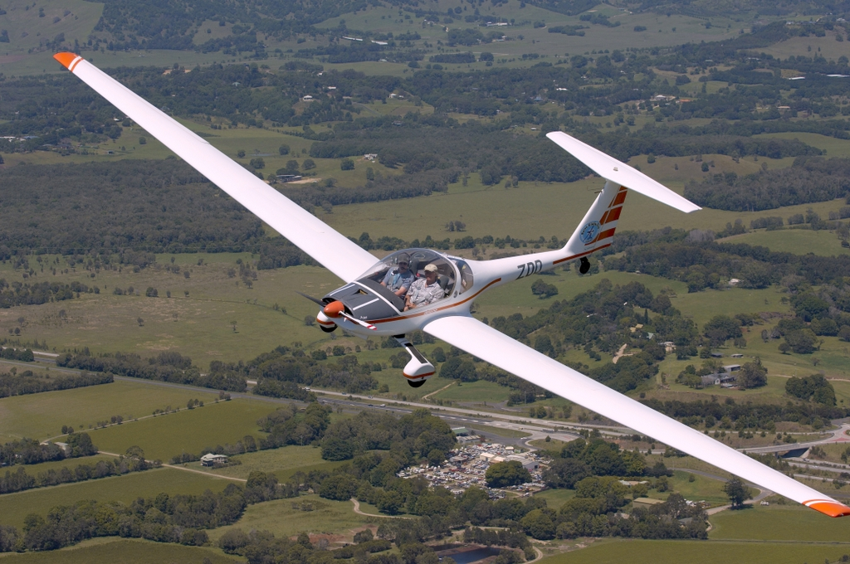
WHAT TO EXPECT NOW YOU HAVE JOINED THE CLUB
All of the people who; participate on the Committee, teach you to fly, act as Duty Pilots, maintain aircraft, clean up, etc are all members and volunteers. They are not paid to perform tasks and, like you, are here to enjoy themselves and, of course, to enjoy gliding. We are a non profit community organisation and not a business where you simply pay your flying fees and leave.
So whenever possible chip in and contribute and if you don’t know what needs doing ask a Committee or senior club member. About two to three times a year the Club has a work day and all members are encouraged to attend. It’s your club and the cleanliness of the clubhouse, hangars and surrounds are your responsibility so ask other members how you can help.
During summer the grass needs cutting and edges done regularly. There is a trimmer in the shed at the back. Ask if you want instruction. Mowing/trimming should be avoided around aircraft.
If you see building maintenance that needs doing, then bring it to the attention of a Committee member or deal with it yourself.

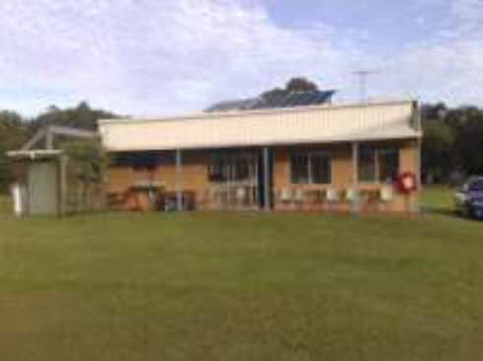
CLUBHOUSE AND HANGARS
The Clubhouse and the hangars are yours and need to be maintained, kept clean and tidy.
The clubhouse, and especially Hangar 1 to which the clubhouse is attached, is the public face of our club. If you see things lying around in either, please put them in their appropriate place or at least on a bench or shelf.
The kitchen must be kept clean. Wash your own dishes and any left by visitors and do not expect other club members to clean up after you.
No aircraft parts or repairs are allowed in the Clubhouse.
Also camping/sleeping in the Clubhouse is generally prohibited except in emergencies.
The Hangars, Fuel Shed and the Clubhouse should be locked at the end of each day unless members are staying over. Members have a “duty of care” to ensure that all aircraft and the club and aircraft owners’ equipment is secure and safe.

AIRCRAFT
The Club leases a number of motor gliders from private owners. These include Dimona H36, Motor Falke, and Grob 109.
You can read the specifications of any of the above by going to www.sailplanedirectory.com.

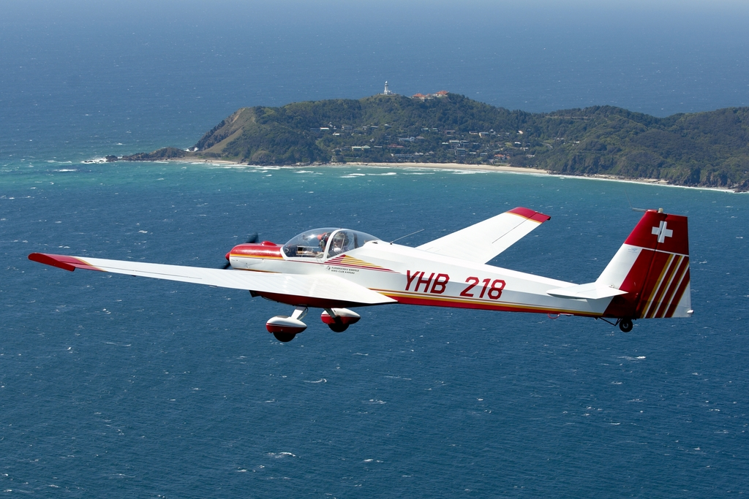

There are also other private aircraft in the hangars. Their owners rent hangar space from the club and must be a member of the club to do this. As we are predominately a gliding club gliders will always have first preference over other light aircraft.

If you are interested in being an owner feel free to approach any of the private owners or watch the
Club email list as often private owners seek new people to co-own with them or may wish to sell outright.

Look after all aircraft as if they were your own. If you damage the aircraft in any way you are responsible and may be required to pay for that repair or to the value of the insurance excess for any significant damage done. Aircraft are insured but if you are the pilot in command, that is, not under tuition with an instructor, then you may be required to pay this excess. Further information is on the noticeboard.

Aircraft are required to be kept clean inside and out and should be washed at the beginning of the day before you fly. As they spend their day in the sun, they require regular polishing on the exposed surfaces to counteract UV light damage. Most have canopy covers which should be fitted after the days flying. Radio headsets should be treated with respect, not handled roughly and covered from the sun when you leave an aircraft outside.

Aircraft canopies should never be left open if the aircraft is unattended outside the hangars especially if it is windy!

INSTRUCTORS
If you wish to book an instructor you should ideally contact the instructor of the day directly or alternatively the club which can advise on whether an instructor and aircraft is available on any given day. Information is also available on the club calendar (see below)

If you haven’t booked instruction, don’t despair, check with the instructor on duty when you get to the airfield to see if a slot is available. You might have to wait. The booking system is there to streamline the process. You may feel more comfortable with some instructors and not with others. Keep in mind, different instructors have different strengths and may help to improve your airmanship.
Always bring your Logbook with you, it is part of your “Licence” to operate a glider and is often required by your instructor. Keep it up to date and remember it is your responsibility to get the instructor to enter the flight notes. If you would like an Instructor to cover certain things, just ask!

FLYING
Instructors are not available everyday as the club has adopted a policy of operating for 4 days a week during which time an instructor may be available. If you have an Independent Operator’s Rating then you can operate at any time.

The Club maintains an internet based Bookings Calendar which you can access from the Club’s website. Go to the site www.byrongliding.com then go to site map on the left of the page, scroll down until you find the club’s calendar/booking page...click this. You will then see if anyone has booked the time you would like or not and which instructor is on duty. Then phone to book a spot for you or you could simply take a chance there will be no more bookings and just turn up!

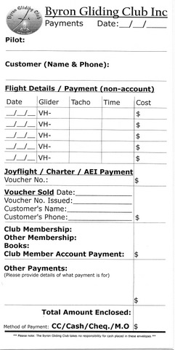
Sometimes you may find that there is a wait to fly as an aircraft may not be available, have been delayed or an instructor is not readily available. That is the nature of a club operation so be patient and maybe look around for some job to be done while you wait or just enjoy the beauty around your clubhouse. You will very early in your lessons realise that there is an element of persistence required in learning to fly a glider but hang in and you will be rewarded with some amazing experiences. Our training system generally produces good club members as well as competent pilots.

After each flight, which may include a number of landings, it is the responsibility of the Pilot in Command to complete the Aircraft Log book in the glider for the flight/s completed. The columns are self explanatory but if you are not sure, please ask an instructor or club member. The log books for all aircraft are used by the Treasurer to determine the cost of the flight/s and to ensure that fee errors are minimal. Please write legibly!

MEMBER’S ACCOUNTS
Your flying account is not a credit account.
At the end of the day, or before leaving, all members are expected to settle their accounts in full. You should keep your account balance positive at all times.
The club reserves the right to charge interest on negative balances at the end of each month.
The club accepts cash, cheques and has an Eftpos and credit card machine in the clubhouse for your convenience and use. All payments are to be placed in the Payments Envelope found on the desk in the main clubhouse area and put into the locked cash drawer. Date, surname, amount and type of payment are critical entries and your Treasurer can get very “agro” if these are not entered properly.
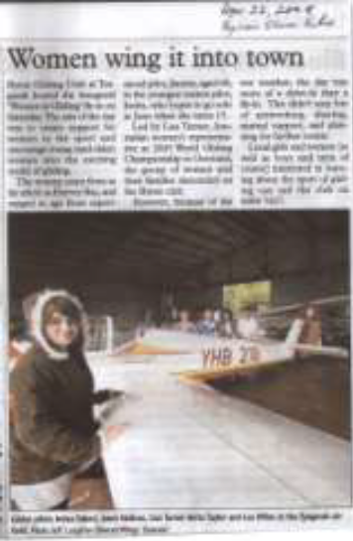
FUEL STORAGE & REFUELLING
The Club maintains a fuel shed which houses aviation fuel and other inflammable materials. The shed is to be locked at all times when no member is at the airfield. When taking fuel for an aircraft the quantity and aircraft rego is to be entered onto the Fuel Use Sheet on the wall inside the shed. Please be accurate in recording the fuel taken as the Club maintains only a tiny cost margin to cover spillage/mistakes. If all lines of the sheet are used please get new sheet from Forms Folder in Clubhouse and deposit the now full sheet into the cash drawer.

EMAIL AND INTERNET
The Club contact information on the site. The official gmail address is for the Committee to communicate with you about Club matters and for you to communicate with the Committee especially to ensure your contact or finance details are up to date, other club members are not connected to this site.
The forum is for you to communicate with other members about any issues regarding “flying”. Remember when using this forum to always respect other members who may not appreciate nonsense emails or who may not have broadband and don’t like their email being held up by time wasting downloads.

VISITORS
The Club get lots of visitors. You may have started as a visitor. One thing we would like to do well is make visitors feel welcome. Regardless of your level of experience, the Club will be delighted if you start a conversation with a visitor and engage them rather than ignoring them and leaving them standing around. Your lack of knowledge is more than made up for by your enthusiasm. Offer them a coffee, drink, or even a flight? Flight fees are on the Club Notice Board.

CAMPING
Club members are able to camp in the area east of the southern hangar and use the Clubhouse amenities. It is expected that campers keep the Clubhouse and camping area clean, tidy and secure. Current camping fees are listed on Club Notice Board.

FUND RAISING
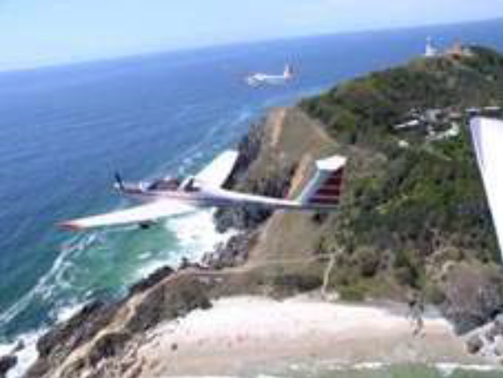
The Club raises funds in a number of ways one of which is our air experience flights which are operated by Club members with an instructor or AEI (Air Experience Instructor) certification. Club members have an incentive to achieve this AEI qualification as the flying time is paid for by the client. These AEF’s are operated by the Club under the GFA rules. Check with an instructor if you would like more information on achieving this rating.
Usually the Pilot in Command collects the money for the flight and fills out a Payment Envelope mentioned earlier. In this case, the envelope is filled out to indicate which aircraft was involved, the Passenger’s surname, and the payment. If a voucher was used, then the voucher number is recorded in the right hand column instead of the monetary amount.
We sell Gift Vouchers which are kept in a folder on the Clubhouse desk or are accessible from our website. If you sell a voucher, write the voucher number in the left hand column next to Voucher # and write the amount in the $ column on the right and put the money or credit card merchant slip into the envelope.
Another way in which the Club raises funds is by offering potential members or members of other Clubs, the opportunity to learn to fly or to convert to motor gliders. Gift vouchers are also available for lessons.
Please note that all funds received by the club are used to finance our operation costs and to promote gliding to the wider community. As an incorporated body no individual member is allowed to gain any financial benefit from these funds.

GLIDER MAINTENANCE
This is an area every glider pilot should get involved in to some degree. Each glider has a little blue book called a Form 1 Maintenance Release. It is kept at all times with the aircraft.
In this book there are two sections worth noting: The first is defects -“minor defects” are little things which will not stop the glider flying, and “major defects” which if entered in the book means you cannot fly the aircraft.
Anyone can enter a defect, but only a Form 2 inspector may clear the aircraft for flight. If you are unsure if a glider is safe to fly, the primary rule is to find someone who has sufficient experience to bring the problem to the notice of an Instructor, a Form 2 Inspector or a senior Pilot.
Secondly in this book you will find a record of the engine and flying hours. These must be updated every time the aircraft has flown. Also you will find the Daily Inspector’s signature to verify that the aircraft has been checked safe to fly for that day. If this has not been entered then you cannot fly.

OPERATIONS MANUAL
Byron Gliding Club has an Operations (Ops) Manual in print or in electronic form and is available at the clubhouse. Please read it. The Club Ops Manual is a guide but remember the Instructor in charge on the day has the final say.

MEMBER SKILLS
Nothing will get done without member input so if you have a skill or business which may be useful for or around the club, let a Committee member know if you would like to help.
A few of examples of skills that will come in handy would be mechanical skills, communication skills for submission writing, grant requests, drawing or artistic skills for sign making, brochure design, marketing skills for Club promotion, sponsorship and lobbing skills for lobbying Councillors, state government departments, even washing up skills are appreciated.

STUDENTS
As a student the club has some expectations of you. Firstly aircraft need to be removed from the hangar in the morning and cleaned and put away at the end of the day. If your lesson is during the day, ensure you refuel and if necessary wipe the wings and fuselage at the end of your flight.
Students may not remove aircraft from the hangar without being instructed on the process. Unfortunately every aircraft fits into the hangar differently so you need to learn how each aircraft is placed. One person should be in charge of the process with the others doing as directed. The process should be done slowly and any individual can yell “stop”. “Hangar Rash” is expensive and very avoidable.
As a student don’t hesitate to ask questions of older members of the club. You won’t know unless you ask!
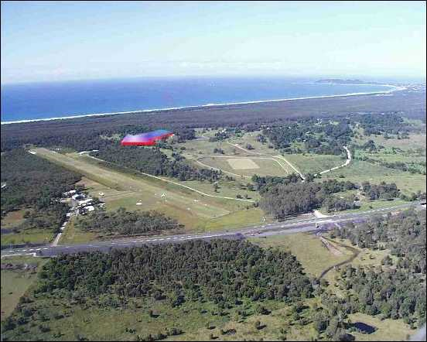
AT THE END OF THE DAY
Relax, have a wine, beer or softie and chew the fat. You will be amazed what you will learn about flying and the other club members. The only rule is that all aircraft are to be put to bed, and the hangar doors shut before the fridge is opened.

Byron Gliding Club Committee

